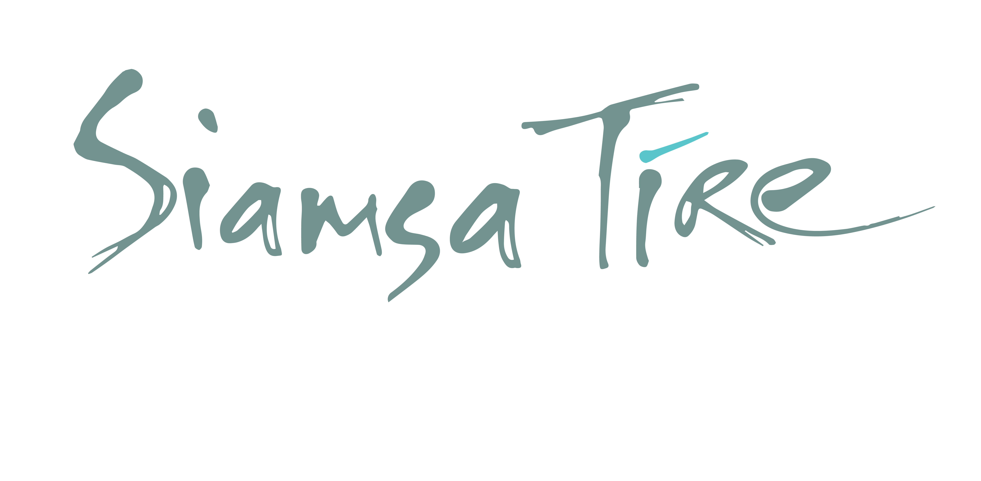

**Exhibition Enquiry Form**

*PLEASE NOTE: THE INFORMATION ON THIS FORM BECOMES PART OF SIAMSA TÍRE CONTRACTS. PLEASE COMPLETE WITH DUE CARE. IF YOU NEED ASSISTANCE COMPLETING THIS FORM, PLEASE CONTACT 066 712 3055 or* [*admin@siamsatire.com*](mailto:admin@siamsatire.com)

|  |  |
| --- | --- |
| **ABOUT YOU** | |
| **EXHIBITOR/COMPANY NAME:** |  |
| **EXHIBITOR ADDRESS:** |  |
| **COMPANY NUMBER *(if registered with Companies Office)*** |  |
| **PRIMARY CONTACT/ARTIST NAME:** |  |
| **CONTACT NUMBER:** |  |
| **CONTACT EMAIL:** |  |
| **WHERE ARE YOU BASED:**   1. **Co. Kerry** 2. **National** 3. **International** |  |
| **FUNDING**   1. **Applying for funding** 2. **Secured funding** 3. **Hire Gallery** 4. **Supports required** |  |
| **EDUCATION & OUTREACH**  **Can you provide:**   1. **School Notes** 2. **Workshops/Guided tours for schools** 3. **Guided tours of exhibition for schools** | (Provide availability and what you can provide) |
| **YOUR SOCIAL MEDIA CHANNELS** | Twitter handle |
| Facebook page |
| Instagram handle |
| YouTube account |
| Spotify account |
| TikTok account |
| Website |

|  |  |
| --- | --- |
| **1st PREFERENCE DATES:**  **(including Installation)** | Get-In:  Opening:  Get-Out: |
| **2nd PREFERENCE DATES:**  **(including Installation)** | Get-In:  Opening:  Get-Out: |
| **3rd PREFERENCE DATES:**  **(including Installation)** | Get-In:  Opening:  Get-Out: |
| **INDICATE GALLERY SPACE REQUIRED** | All three Gallery spaces ☐  Main round Gallery ☐  Side Gallery ☐  Entry Gallery ☐ |

## **A**

|  |  |
| --- | --- |
| **ABOUT YOUR EXHIBITION** | |
| **Exhibition Title** |  |
| **Exhibition genre (type of media)** |  |
| **Exhibition Description** |  |
| **Is the Exhibition touring elsewhere? (List other venues and dates)** |  |  |  |  |
| **Target Audience/s** | Please tick as appropriate:  General ☐  Families ☐  Children (0-6) ☐  Children (6 – 12) ☐  Youth (16-24) ☐  Target Group(s) ☐  Artists/Arts Professionals ☐ |  |  |  |
| **Age Suitability (from)** |  |  |  |  |
| **Details of any material that may be age sensitive or offensive** |  |  |  |  |
| **Partners/Nominated Curator** |  |
| **Value of exhibition & Insurance** |  |
| **How will you Transport your artwork** |  |
| **Will you require an opening event? (Provide suggested date)** |  |
| **Are your artwork pieces on sale? If yes, you need to provide a catalogue & price list** |  |
| **Additional Information:**   1. **Artist Biography** 2. **Images of artwork** 3. **Proposal** |  |